Assignment 15.6
Build and Deploy Hadoop word count program using Gradle
Input file:
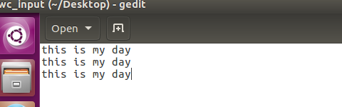

Step1: CREATED A Project”wordcount” IN TERMINAL AND In source/main/java folder added mapper.jav, driver.java, reducer.Java as shown
In root directory added a build.gradle file and added the following dependencies (image shown below of gradle build)

USE GRADLE BUILD TO build the Gradle project:

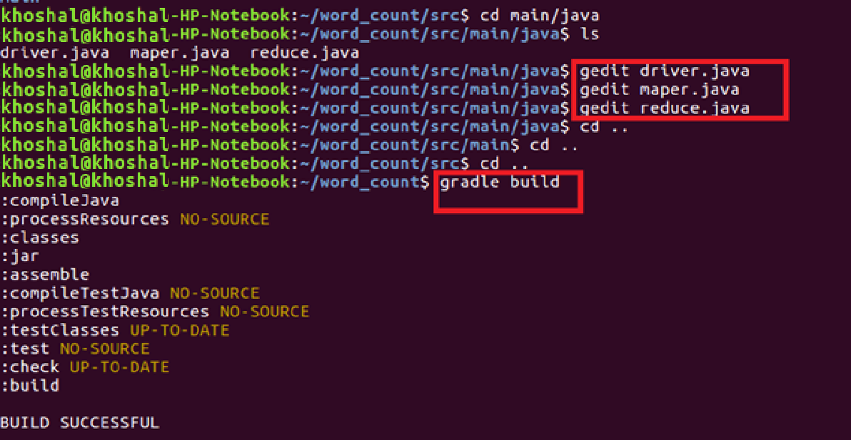
Step3: Used Gradle eclipse to build the project and classpath that are required for eclipse
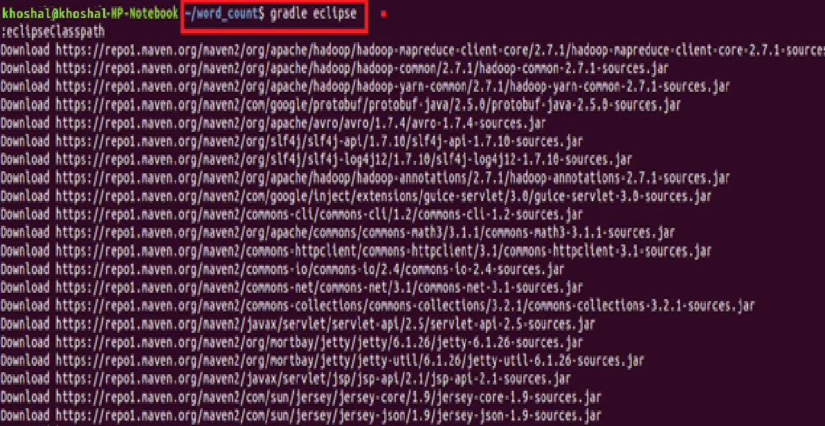
Build Success: build successful will be displayed and word count jar file will be created in libs
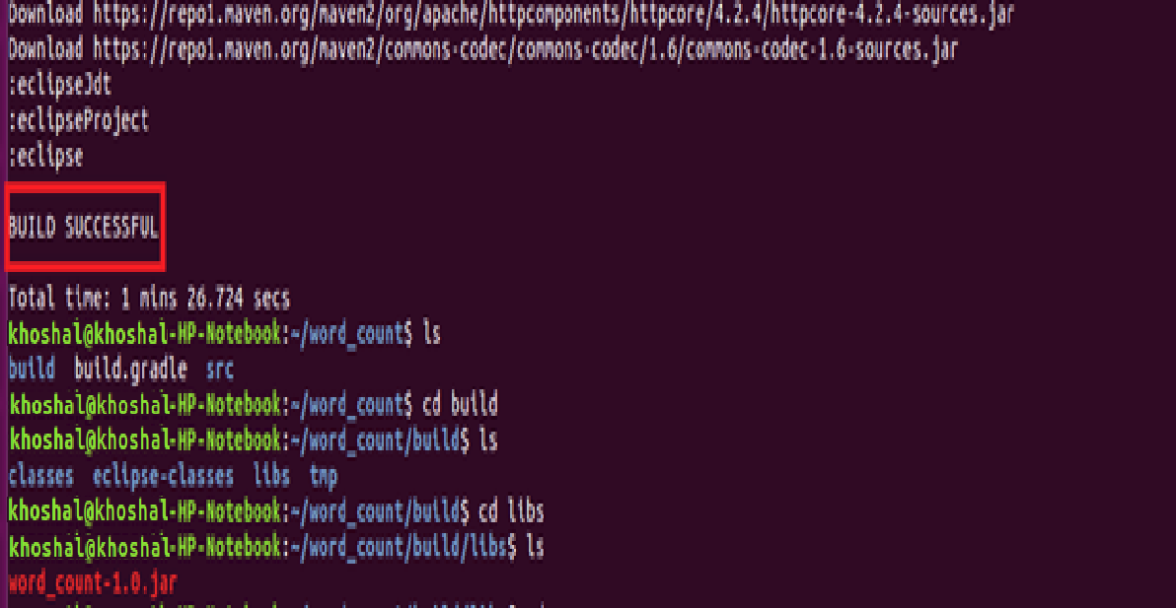
Step4: Importing project into Eclipse:
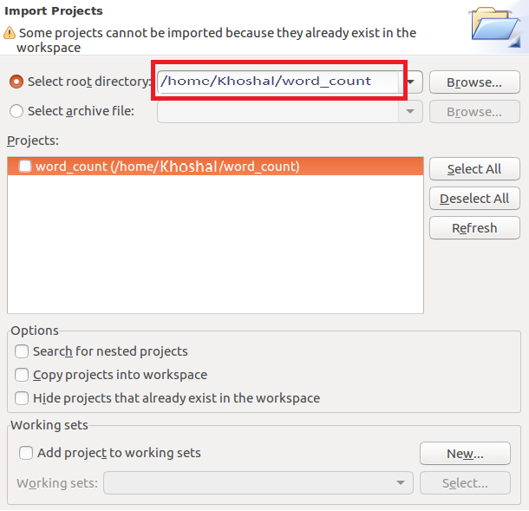
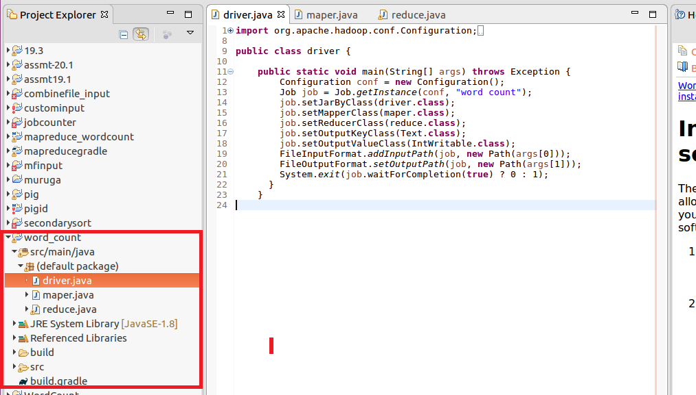

Mapper:
In mappersplit the words by space and send word as key and count of 1 as value
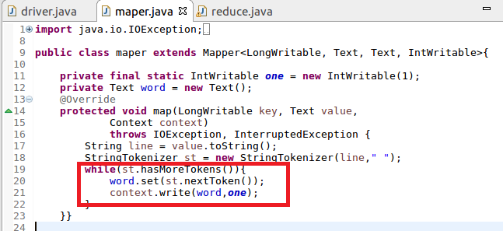
Reducer:
Count the total occurrence of words
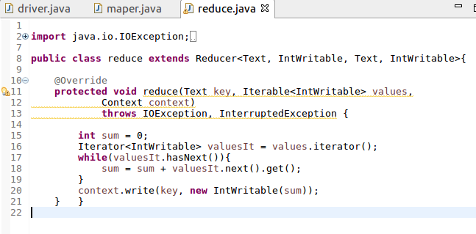
Build gradle:
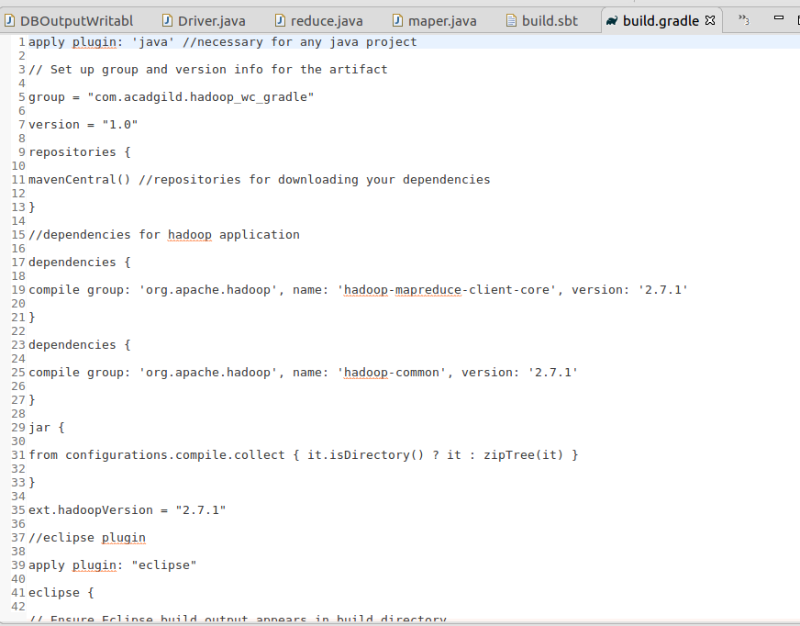

Step5: Running jar file create d by gradle:
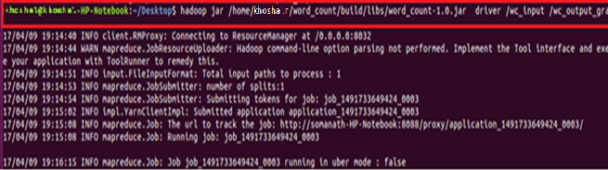
Output:
